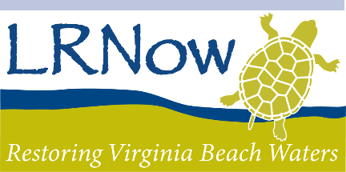

Do you have a passion for digital photography? Virginia Beach is legendary for its beauty and the bounty of its wildlife. Enter the 21st Annual LRNow Photo Contest and share your beautiful photos with the world.

Contest Rules

1. All photographs must be taken anywhere in Virginia Beach.

2. Submission Format:
All artwork should be submitted via email as an attachment or link to download to
Dominique@LRNow.org by November 15, 2023
Photo files should be no larger than 50MB
Photo files must be 300 dpi and .jpeg format
Photo resolution should not exceed 3000 x 3000 pixels
Design files must be a PDF or vector file format (if submitting a vector file, include jpeg for judging)

3. The contest begins on August 14th, 2023 and ends November 15th, 2023. Winners will be announced via email before the end of November and shared on the LRNow website and social media. Only winners will be personally notified of the contest outcome. Entries will not be returned.

4. Winners will be announced at the 2023 Volunteer Appreciation Party in December. Winners will be featured in our 2024 Annual Report.

5. Photographers may submit up to 5 photographs for consideration. Submitted photographs must be the property of the entrant.

6. Winning photos will be chosen in four categories:
a. Wildlife
b. Landscape
c. Humans and the environment – positive and negative examples
d. Conservation and sustainability – Ex. Rain gardens, living shorelines, energy efficiency, alternative energy, native plants, buffer gardens, waste reduction, etc.

7. The contest is open to both amateur and professional photographers. Employees of Lynnhaven River NOW are not eligible.

8. All entries must contain a completed entry form, including current contact information, caption details, and artist release. Photos should be numbered to correspond with the caption details.

9. Official judging will be performed by a panel of Lynnhaven River NOW employees and select professional advisors. Judges will make their selections based on subject matter, composition, focus, lighting, uniqueness, and impact. All decisions are final and at the discretion of LRNow.

10. We are not responsible for lost or misdirected entries.

11. We reserve the right to use all entries in Lynnhaven River NOW’s materials (print materials, presentations, promotions, and the Internet).

