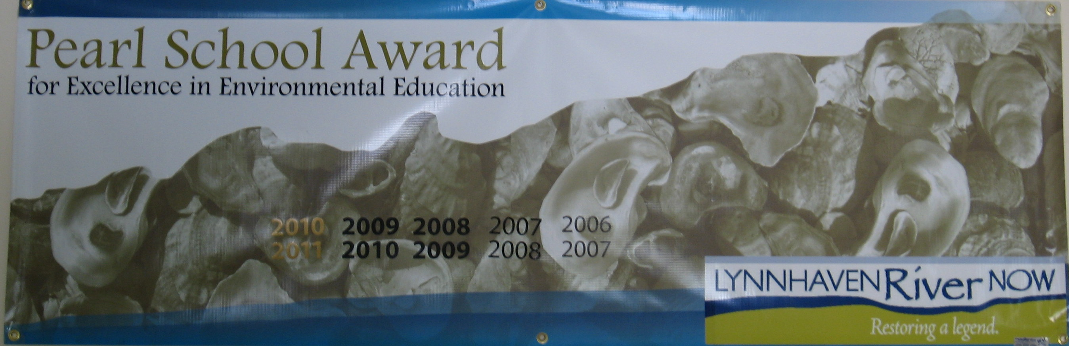

Lynnhaven River NOW Pearl School Program
Information and Resources for 2022-2023

The teachers in the public and private schools in our watershed and throughout the City of Virginia Beach are some of the most effective spokespeople in our community for water stewardship. You are doing a great job not only helping students understand watershed concepts, but also in developing an ethic of environmental responsibility and stewardship despite the challenges you have had over the past two years.

The goal of the Pearl School Program is to encourage and support the efforts of these teachers and schools. Through the Pearl School Program, schools will be able to earn points toward the Pearl School Award by carrying out educational and service projects in their schools. These projects teach environmental concepts, including understanding watersheds, their unique characteristics, and problems while encouraging students to take an active role in tackling some of our environmental challenges through service projects in their schools and communities.

Helping to Restore the Legend

How the Pearl School Program Works

The Pearl School Award is a way of recognizing schools that are providing their student body with a variety of environmental activities, exceeding the requirements of their curriculum, and including activities recognized by the Lynnhaven River NOW Pearl School Award as outlined in this brochure. The purpose of this program is to foster good stewards, environmental education, and sustainability. This is not a competition and Schools do not compete against each other.

To earn a Pearl School Award, the initial year and in subsequent years, a school must complete projects that add up to their level’s required number of points. These projects must be documented, listing the teacher, and project points.
Having multiple grade levels and teachers involved in these projects is strongly encouraged. This gives the entire school “ownership” of this award and in some cases, additional points are awarded.

POINT REQUIREMENTS

ELEMENTARY & PRESCHOOLS

First Year - 100 points
50 points in subsequent years

MIDDLE SCHOOLS

First Year - 150 points
75 points in subsequent years

HIGH SCHOOLS

First Year - 150 points
75 points in subsequent years

NOTE:
Schools that achieve the award initially must apply within the next two years to be eligible for the subsequent year scoring requirements.
Schools waiting longer than two years must meet the first year’s criteria to receive their award. This applies to all the schools that choose not to submit an application last year. You must submit an application this year or meet the first year’s criteria.

Award applications MUST be submitted by 5pm Friday, May 5, 2023 to be eligible for the 2021-2022 award. You may edit your application at any time up until the submission date.

Schools, teams, and teachers are urged to review the on-line application https://www.lynnhavenrivernow.org/pearl-school-award/
for ideas and point assignments. Ideas for programs and projects not on the list may be designed and submitted in advance for approval.

Please note that a large project completed and receiving maximum credit in its completion year can be counted at half value in subsequent years if the project continues to be maintained, used in a learning capacity, and is documented and explained on the application.
Limits may apply on some programs. *See application form for specific details.

Schools earning the Pearl School status for the first time will be awarded with a large attractive banner to hang in the lobby of the school, as pictured on the front cover of this flyer. The initial year that the school earns the award will appear on the banner. Each additional year the school earns their award, a new set of dates will be sent to the school to be added to the banner.

Lynnhaven River NOW will work to the best of our ability to present the initial year’s banner at a school event, meeting or on the school’s televised announcements. Please think about this date as you fill out your Pearl School application. Advanced planning for this initial presentation helps to ensure that the students who have worked to achieve this award are able to enjoy the recognition of this achievement. Subsequent years’ award materials will be mailed to the school unless other arrangements are required.

Below are project categories and explanation or resources to help you plan and execute projects in that category.
Please see the Application for the FULL listing of projects.

To learn more about our Pearl School program, please call us at 757-962-5398 or email Education@LRNow.org

For all the resources below, please check the websites to see if the competition/event or opportunity has been canceled or altered due to Covid-19.

PROJECT CATEGORIES/RESOURCES

Individual Study Projects: 3 Points Each
These are projects that students have completed either as part of a team or individually. They can be projects completed through a club/organization outside of school (4-H, scouts, etc.), in school or with their family. These have been expanded to include the entire family.

Competitions students can take part in:
- Tidewater Science & Engineering Fair http://www.tidewatersciencecongress.org
- Blue Crab Bowl http://web.vims.edu/BCB/
- Envirothon https://www.envirothon.org/the-competition/current-competition
- Kid Wind Challenge https://www.kidwind.org/challenge

Pearl Home Block Captain - To be a block captain, a student must sign up at least 6 of their neighbors/friends to be Pearl Homes. They will receive a certificate and have their name listed in our Annual Report. Contact us at Education@LRNow.org for more information and to sign up.

Help with Social Media Campaigns-
- Take pictures of your dogs and write something about how important it is to Scoop the Poop.
- Celebrate your favorite tree through written words, pictures, drawings, etc.
- Download Wally the Water Drop from the website and take him to your favorite neighborhood park. Take a picture and send it to us, along with Wally’s location.

Group I Projects: 5 Points Each
Group I projects give schools credit for one-time interactions or basic environmental projects, such as school-dictated recycling efforts. Group I Projects have no limit, with exception of individual attendance of workshops or lectures.

- Storm Drain Marking Program: This program is run through the Virginia Beach Department of Stormwater Management. Students go out and find the storm drains in a neighborhood or around the school. If they are not marked, they mark them with metal discs (all supplies are provided free of charge). If they are already marked, then the GPS coordinates are recorded and sent to the city for inclusion on the GIS map. For more Information, contact Education@LRNow.org

- Rain Barrels: You can purchase rain barrels through LRNow. The Farmer’s Market has rain barrel workshops where you can make a rain barrel to take home. www.vbmg.org/register-for-events.html

- Avoid using balloons: Check out these websites for other ideas on how to memorialize or celebrate events without balloons:

https://balloonsblow.org/
https://greenecofriend.co.uk/eco-friendly-alternatives-to-balloons/

Group II Projects: 10 Points Each
Group II Projects give schools credit for grade level or school-wide interactions and recurring environmental projects, such as regularly scheduled schoolyard trash clean-ups and recycling efforts.

- Recycling Projects outside of curbside recycling: (check stores for COVID restrictions)
https://www.terracycle.com/en-US/brigades
http://www.earth911.com/recycling-center-search-guides/
https://www.terracycle.com/en-US/brigades/kroger

- Participate in Green Apple Day of Service. Information at http://www.mygreenapple.org/
- Receive the Green Ribbon School Award, Virginia Naturally Award or another Environmental Award. Information at:
http://www.doe.virginia.gov/instruction/environmental_literacy/index.shtml

- Citizen Science/Community Science Projects:
https://scistarter.com/citizenscience.html
https://www.nationalgeographic.org/idea/citizen-science-projects/
https://citynaturechallenge.org/

Group III Projects: 20 Points Each
Group III projects give schools credit for school or community-wide programs and projects that have a sustaining impact on the school population and beyond.

- Adopt a roadway or waterway through the City of Virginia Beach’s Adopt-a-Space Program.
www.vbgov.com/government/departments/parks-recreation/parks-trails/caring-for-our-parks/Pages/adopt-a-programs.aspx
- Oyster Gardening - contact: Oyster Reef Keepers laurie@oysterreefkeeper.org
- LRNow SOS (Save Oyster Shell) Program - http://www.lynnhavenrivernow.org/saving-oyster-shells

- Ocean Friendly Garden Info Surfrider Foundation – https://www.surfrider.org/programs/ocean-friendly-gardens

20th Anniversary Opportunities (20 for 20)- Good through December 31, 2022
- Create a short video wishing LRNow a Happy 20th Anniversary. Include your Pearl School Banner and at least one project you have done to green your school in the video. The video must be filmed horizontally, be no more than 10 seconds long and included the name of the school and either the teacher and grade or adult supervisor if a club.
- Send us a picture of your school 20 years ago (if possible) and one of it now, showing off the results of an outdoor project to improve drainage, wildlife habitat or learning opportunities.
- Send us your dreams about how you would like to improve sustainability at your school and what that might look like in 20 years. This can be in the form of a poem, essay, photos, or 2D artwork.
- Add to your Facebook page and/or webpage information about your Pearl School Award and link it to our website for more information.
- 20 in 20 Litter Pick Up. Pick up either 20 pieces of litter per day over 20 days or 20 pounds of litter over 20 days. Send us pictures and the approximate weight of the litter at the end of the 20 days. See the website for more information.( Good only through November 2022).

Award Eligibility for 2022-2023 School Year-
Applications are due by 5 pm on Friday, May 5, 2023
All projects completed between February 1, 2021 and May 1, 2022 are eligible for this award. Applications are done on Google Forms and can be scanned, emailed, mailed, or hand delivered to the address below.

Applications must be complete and received by the deadline for consideration.

Email: Education@LRNow.org
Phone: (757) 962-5398
Mailing Address: Pearl School Programs 3663 Marlin Bay Dr. VA Beach, VA 23455

Any problems with the submission, please contact us right away. Schools will be notified when their application is received. Do not assume your application has been received if you have not received an acknowledgement from us.
Always keep a detailed copy of your application.

